Experiment 8: Student Counselling System
Aim
To create a simple cloud-based Student Counselling System using a cloud service provider to demonstrate SaaS.
Algorithm
1. Open Zoho Creator and create a new application.
2. Create a form named Student Counselling System.
3. Add fields such as Student Name, Age, Address, Phone Number, and Email.
4. Add fields for Subjects Studied and Year of Passing.
5. Add a field for Percentage of Marks.
6. Add a field for Domain Interest.
7. Save the form and publish the application.
8. Enter student details and view the submitted records.
Implementation
Input
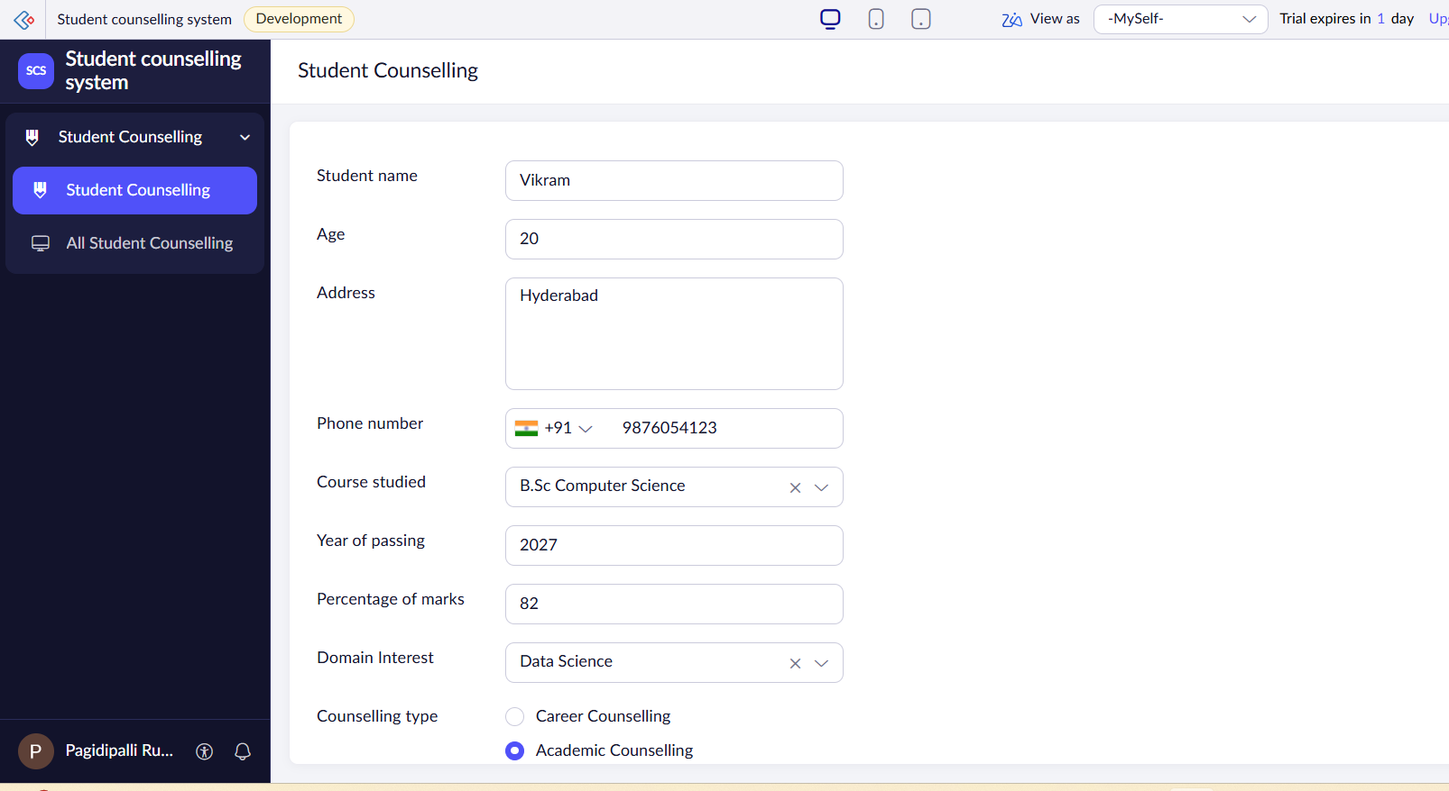
Output
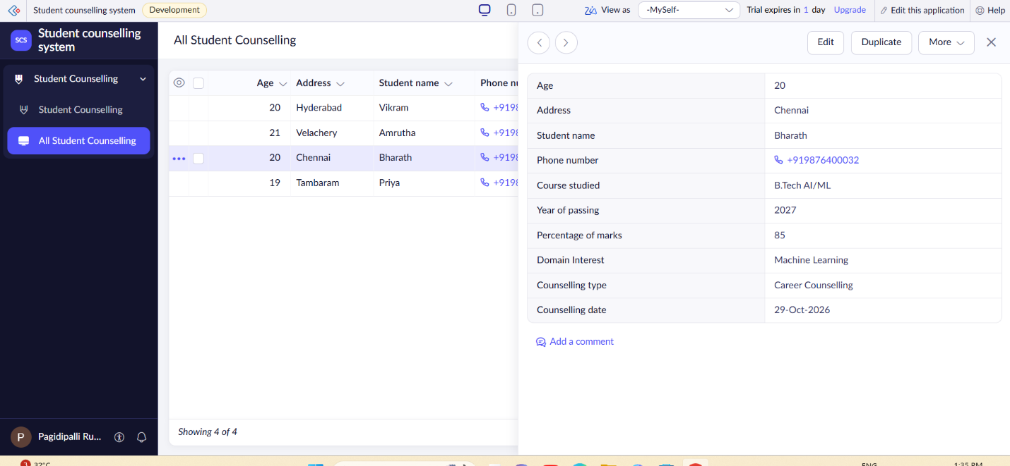

Result
Thus, a cloud-based Student Counselling System was created successfully to maintain student academic details and domain interests for counselling purposes.

